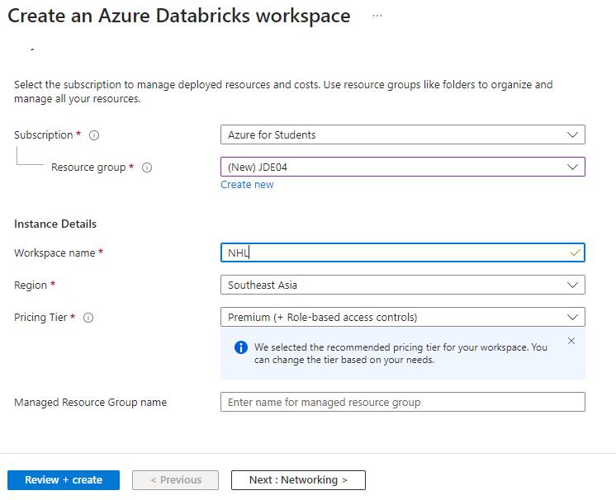

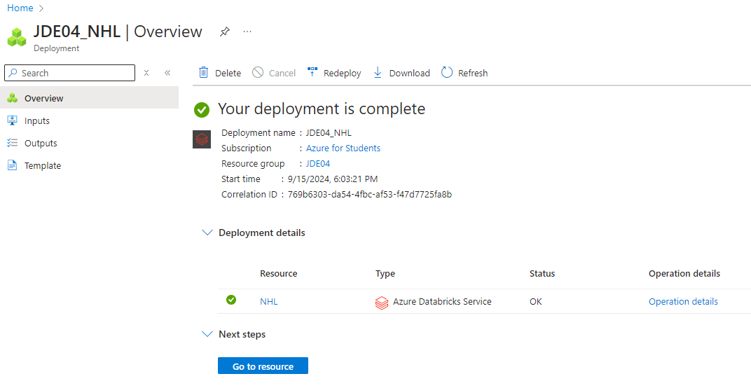
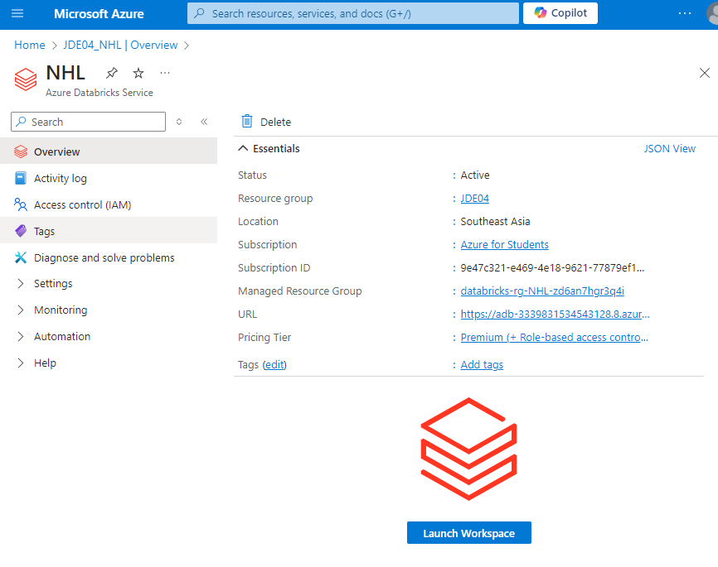

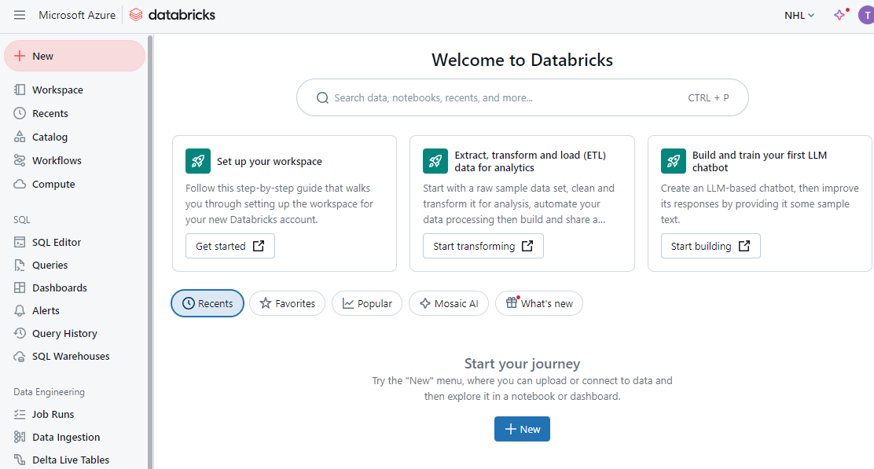
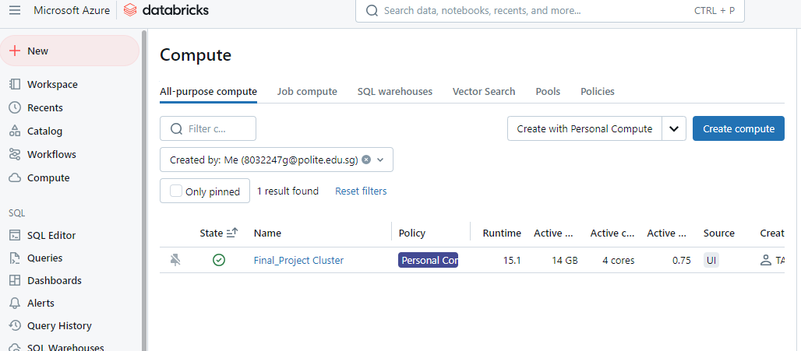
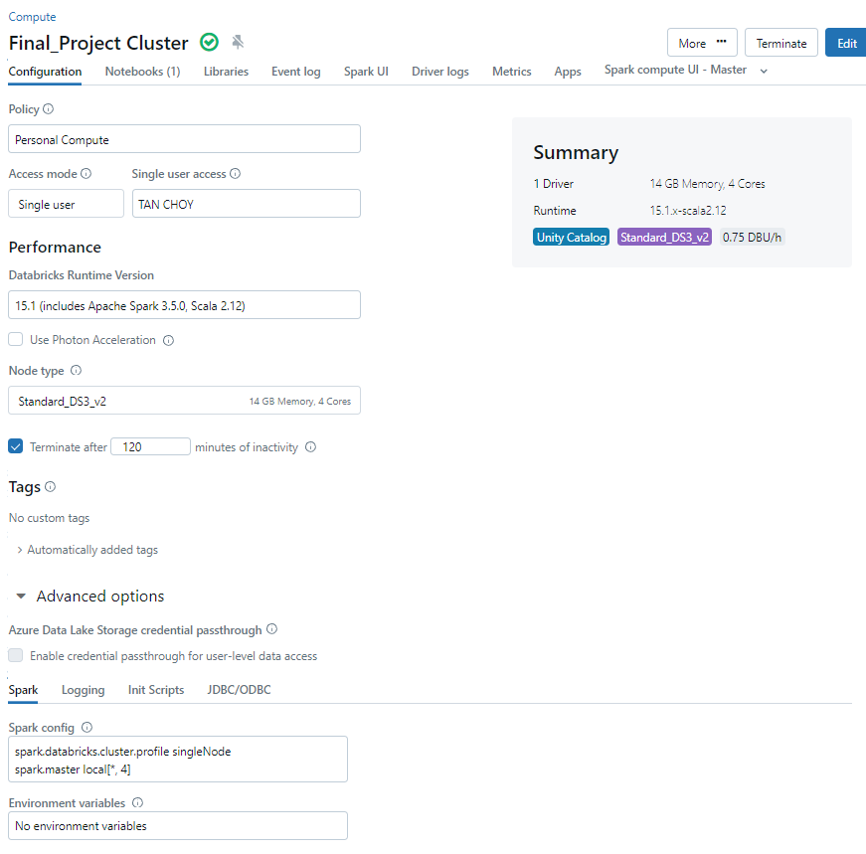

https://community.databricks.com/t5/get-started-guides/getting-started-with-databricks-build-a-simple-lakehouse/ta-p/67404
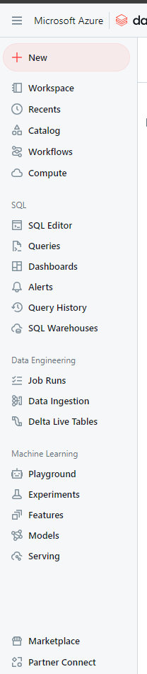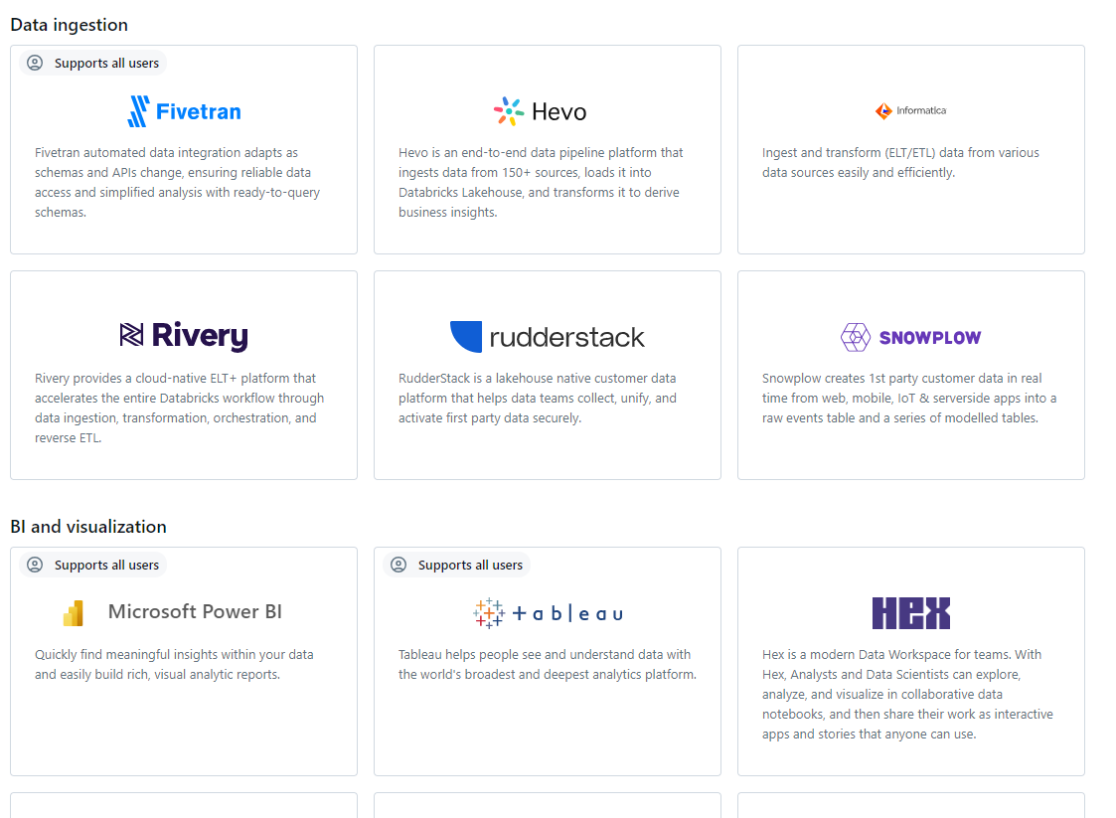
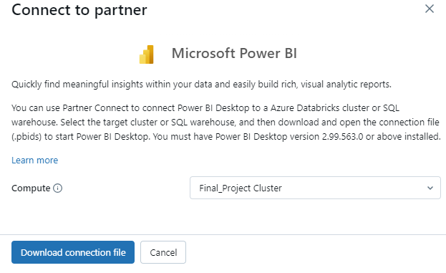
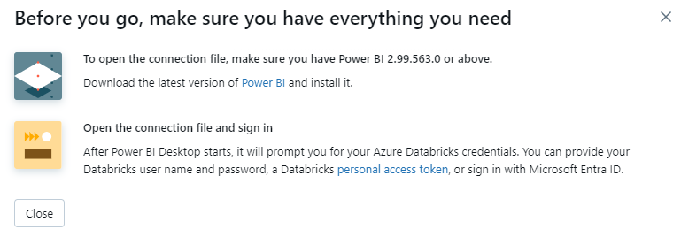

Upload Kaggle API key
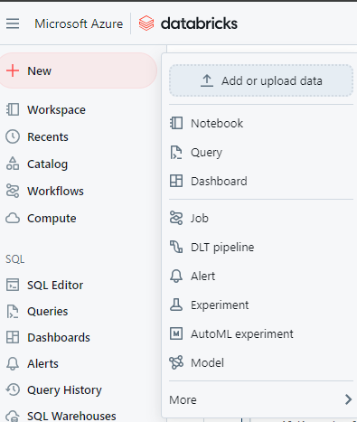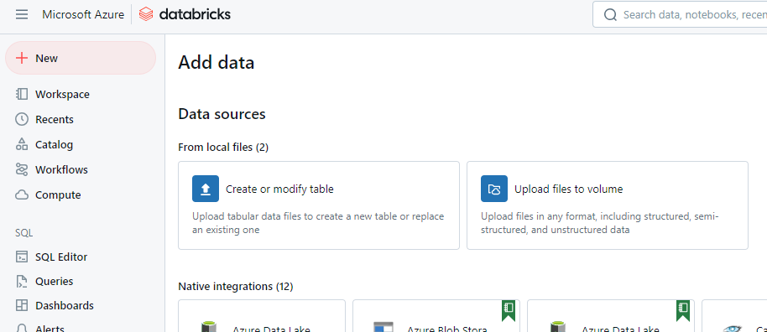

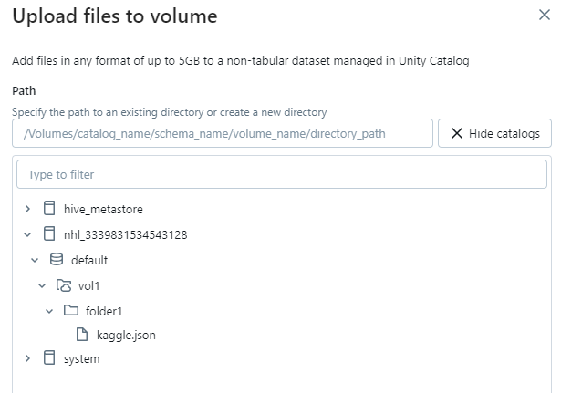
Notebook:
pip install kaggle
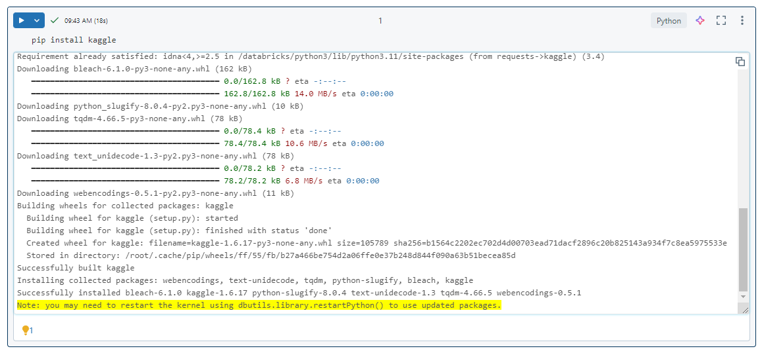
dbutils.library.restartPython()
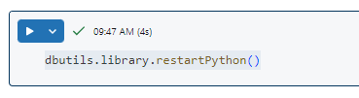
%sh
kaggle datasets download -d nicholasjhana/energy-consumption-generation-prices-and-weather -p /dbfs/FileStore/tables/
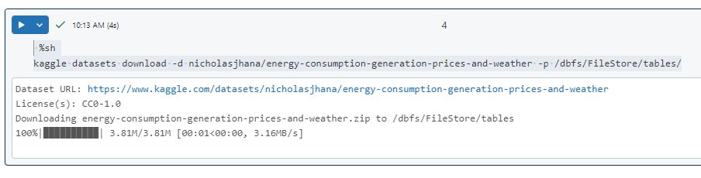
display(dbutils.fs.ls("/FileStore/tables/"))
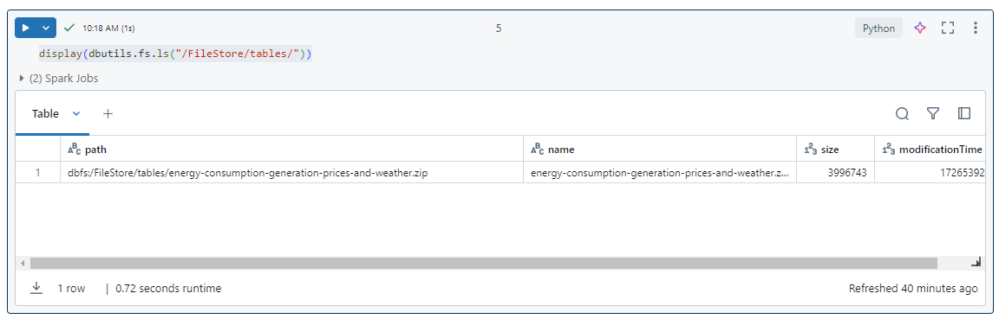
dbutils.fs.mv("/FileStore/tables/energy-consumption-generation-prices-and-weather.zip", "/FileStore/tables/Test_1/energy-consumption-generation-prices-and-weather.zip")
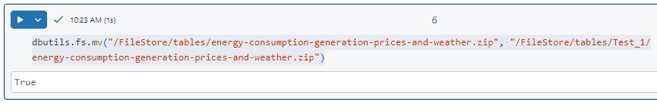
import os
import zipfile

# name of the zip file you want to unzip
local_zip = '/dbfs/FileStore/tables/Test_1/energy-consumption-generation-prices-and-weather.zip'

# opening a file with mode parameter 'r' : read existing file
zip_ref = zipfile.ZipFile(local_zip, 'r')

# extract all contents of the zip file
zip_ref.extractall('/dbfs/FileStore/tables/Test_1/')

# close the file
zip_ref.close()
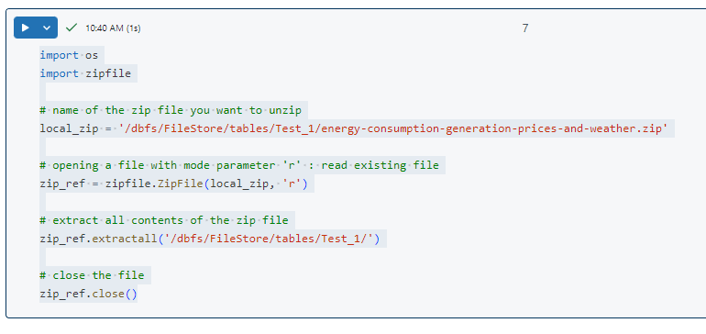

display(dbutils.fs.ls("/FileStore/tables/Test_1/"))
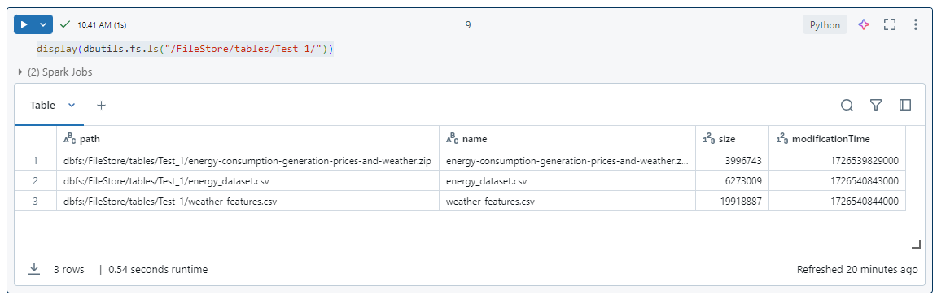
spark_energy_df = spark.read.format("csv").option("header", "true").option("inferSchema", "true").load("/FileStore/tables/Test_1/energy_dataset.csv")
display(spark_energy_df)
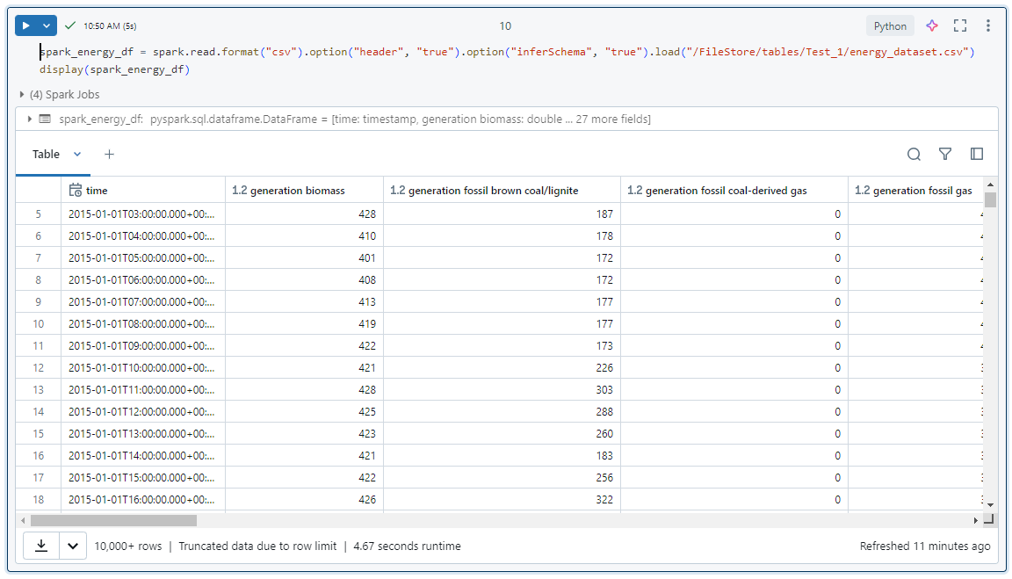

type(spark_energy_df)
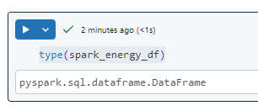

pandas_df = spark_energy_df.toPandas()
pandas_df.head()
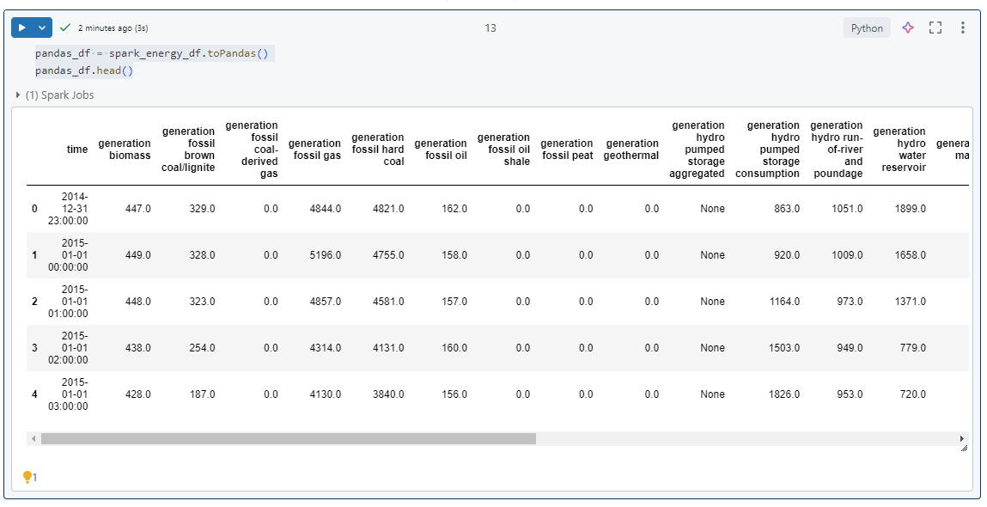
Convert df to SQL table
spark_energy_df.write.mode('overwrite').saveAsTable('energy')
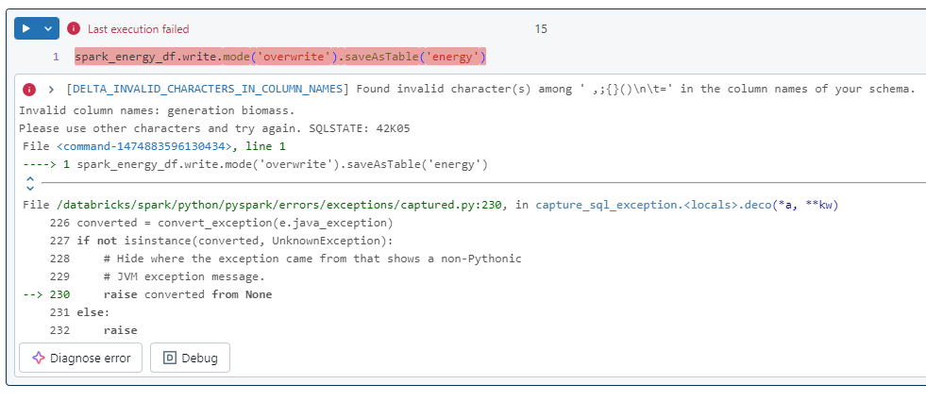
The error message suggests that the column name "generation biomass" contains invalid characters. To fix this issue, you can rename the column using the withColumnRenamed function before saving the table.
spark_energy_df = spark_energy_df.withColumnRenamed("generation biomass", "generation_biomass")
spark_energy_df.write.mode('overwrite').saveAsTable('energy')

